

**2022 Formula Hybrid+Electric Electrical System Form 2 (ESF-2)**

## INTRODUCTION

The goal of the ESF is to ensure that vehicles are as safe as possible, and that they comply with the Formula Hybrid+Electric completion rules. The ESF is divided into fourteen main sections:

1. System Overview
2. Operating Voltage
3. Safety Circuit
4. TSMP
5. Cables & Fusing
6. Motors
7. Isolation & Insulation
8. IMD
9. AMS
10. Accumulator & Container
11. Pre-Charge & Discharge
12. Torque Control
13. GLV
14. Charger

A clear, concise ESF will help you to build a better car. It will also help you to pass tech testing as most common tech problems can be addressed before the car reaches the track.

**IMPORTANT INSTRUCTIONS AND REQUIREMENTS  
*Read carefully!***

1. Every part of this ESF must be filled with content. If a section is not relevant to your vehicle, mark it as “N/A” and describe briefly why not.
2. Please leave the written instructions in place and add your responses below them.
3. All figures and tables must be included. An ESF with incomplete tables or figures will be rejected.
4. The maximum length of a complete ESF is 100 pages.
5. Note that many fields ask for information that was submitted in your ESF-1. This information must be reentered – in some cases will be different than what was entered in ESF-1, which is OK.
6. Submit this document in Word format *– do not convert it to PDF!*Submit to: <https://formulahybridupload.supportsystem.com/>

**ESF-2 REVIEW PROCESS**

Feedback on your ESF occurs through both your team’s Google Doc and the FH ticket system at: <https://formulahybridelectric.supportsystem.com/>

Your ESF will be reviewed by a team of “section reviewers” - experts in specific areas of the FH rules.

Reviewers will add comments coded with “//” for an informational comment, or “!!!” indicating that more information is needed, or that a concern is raised, for example:

**// This diagram is well done. A suggestion in future would be to …**

**!!! We have a concern regarding your accumulator construction - how did you calculate required fuse capacity?**

No action is required for informational (//) comments.

(!!!) comments **require action** - either by responding to the comment in the Google doc, or opening a rules ticket (and adding a response, e.g., “See FH Ticket 1234 for resolution”.

When a (!!!) comment is resolved, you or the inspector involved may indicate this with a final comment:

**// RESOLVED //**

*If you have not received a response to a critical Google doc question, please open a follow-up ticket at:* <https://formulahybridelectric.supportsystem.com/>

The ESF2 is a tool which was created to improve the probability that your vehicle will pass the electrical inspections on its first try.   
  
It is up to you and your team to follow up on all open items.

TITLE PAGE

*Please include team logo, car picture, etc..*

|  |  |
| --- | --- |
| University Name: | University Of Vermont |
| Team Name: | AERO (Alternative Energy Racing Organization) |
| Car Number: | 208 |

**Main Team Contact for ESF related questions:**

|  |  |
| --- | --- |
| Name: | Colin Grund |
| e-mail: | cgrund@uvm.edu |

**Table of Contents**

INTRODUCTION i

**TITLE PAGE iii**

**I** **List of Figures vii**

**II** **List of Tables viii**

**III** **List of Abbreviations ix**

**Section 1** **Vehicle Overview 1**

**Section 2** **Operating Voltage 4**

**Section 3** **Safety Circuit 5**

3.1 Shutdown Circuit 5

3.2 Shutdown System Interlocks 6

**Section 4** **Indicator Operation 7**

4.1 Tractive System Active Lamp (TSAL) 7

4.2 Safety Systems OK Lamp (SSOK) 7

4.3 Ready-To-Drive-Sound (RTDS) 7

**Section 5** **TSMP 8**

5.1 Tractive System Measurement Points (TSMP) 8

**Section 6** **Cables & Fusing 9**

6.1 Fusing & Overcurrent Protection 9

6.2 Component Fusing 9

6.3 System Wire Tables 10

**Section 7** **Motors 11**

7.1 Motor(s) 11

7.2 Motor Controller 11

**Section 8** **Isolation & Insulation 13**

8.1 Separation of Tractive System and Grounded Low Voltage System 13

8.2 Grounding System 13

8.3 Conductive Panel Grounding 13

8.4 Isolation 14

8.5 Conduit 15

8.6 Shielded dual-insulated cable 15

8.7 Firewall(s) 15

Description/materials 15

**Section 9** **Printed Circuit Boards 16**

**Section 10** **IMD 17**

10.1 IMD 17

10.2 Reset / Latching for IMD and AMS 17

**Section 11** **AMS 18**

11.1 Accumulator Management System (AMS) 18

**Section 12** **Accumulator and Container 19**

12.1 Accumulator Pack 19

12.2 Cell description 20

12.3 Cell configuration 20

12.4 Segment Maintenance Disconnect 20

12.5 Lithium-Ion Pouch Cells 21

12.6 Cell temperature monitoring 21

12.7 Accumulator Isolation Relays (AIR) 22

12.8 Accumulator wiring, cables, current calculations 22

12.9 Accumulator indicator 22

12.10 Accumulator Container/Housing 22

12.11 HV Disconnect (HVD) 23

**Section 13** **Pre-charge / Discharge 24**

13.1 Pre-Charge circuitry 24

13.2 Discharge circuitry 24

**Section 14** **Torque Control 26**

14.1 Accelerator Actuator / Throttle Position Sensor 26

14.2 Accelerator / throttle position encoder error check 26

**Section 15** **GLV 27**

15.1 GLV System Data 27

**Section 16** **Charger 28**

16.1 Charging 28

**Section 17** **Appendices 30**

# List of Figures

Figure 1 - Electrical System Block Diagram 3

Figure 2 - Drawings showing the vehicle from the front, top, and side 3

Figure 3 - Locations of all major TS components 3

Figure 4 - TSV Wiring Schematic 3

Figure 5 – Safety Shutdown Circuit Schematic 5

Figure 6 – Location of Shutdown Circuit Components 6

Figure 7 - Shutdown State Diagram (if non-standard) 6

Figure 8 - TS and GLV separation 13

Figure 9 - Team Designed PCB Layout 13

Figure 10 – Charging Circuit with fusing 28

*Must be hyperlinked!*

# List of Tables

Table 1- General Electrical System Parameters 4

Table 2 - Switches& devices in the shutdown circuit 5

Table 3 - Shutdown circuit Current Draw 6

Table 4 – TSMP Resistor Data 8

Table 5 - Fuse Table 9

Table 6 - Component Fuse Ratings 9

Table 7 - System Wire Table 10

Table 8 - Motor Data 11

Table 9 - Motor Controller Data 12

Table 10 – Purchased Components 14

Table 11 – List of Containers with TS and GLV wiring 14

Table 12- Insulating Materials 14

Table 13 - Conduit Data 15

Table 14 - Shielded Dual Insulated Cable Data 15

Table 15 - PCB Spacings 16

Table 16 - Parameters of the IMD 17

Table 17 - AMS Data 18

Table 18 - Main accumulator parameters 19

Table 19 - Main cell specification 20

Table 20 - SMD Data 21

Table 21 - Cell Temperature Monitoring 21

Table 22 - AIR data 22

Table 23 - Data for the pre-charge resistor 24

Table 24 - Data of the pre-charge relay 24

Table 25 - Discharge circuit data 25

Table 26 - Throttle Position encoder data 26

Table 27- GLV System Data 27

Table 28 - Charger data 29

*Must be hyperlinked*!

# List of Abbreviations

AIR Accumulator Isolation Relay

AMS Accumulator Management System

BRB Big Red Button

FH Rules Formula Hybrid Rule

GLV Grounded Low-Voltage

GLVMS Grounded Low Voltage Master Switch.

IMD Insulation Monitoring Device

RTDS Ready To Drive Sound

SMD Segment Maintenance Disconnect

SSOK Safety Systems OK

TS Tractive System

TSAL Tractive System Active Light

TSMP Tractive System Measurement Point

TSMS Tractive System Master Switch.

TSV Tractive System Voltage

***(Add additional abbreviations or acronyms specific to your diagrams or schematics)***

# Vehicle Overview

Person primarily responsible for this section:

|  |  |
| --- | --- |
| Name: | Colin Grund |
| e-mail: | cgrund@uvm.edu |

Check the appropriate boxes:

**Vehicle is**

☐ New (built on an entirely new frame)

☐ New, but built on a pre-existing frame

X Updated from a previous year vehicle

**Architecture**

☐ Hybrid

☐ Series

☐ Parallel

☐ Hybrid in Progress (HIP[1])

X Electric-only

**Drive**

☐ Front wheel

X Rear wheel

☐ All-wheel

**Regenerative braking**

☐ Front wheels

X Rear wheels

☐ None

**NARRATIVE OVERVIEW**

*Provide a brief, concise description of the vehicles main electrical systems including tractive system, accumulator, hybrid type (series or parallel) and method of mechanical coupling to wheels. Describe any innovative or unusual aspects of the design.*

Include the following figures:

* **Figure 1** – an electrical system block diagram showing all major parts associated with the tractive-system. (Not detailed wiring).
* **Figure 2** – Drawings or photographs showing the vehicle from the front, top, and side
* **Figure 3** – A wiring diagram superimposed on a top view of the vehicle showing the locations of all major TS components and the routing of TS wiring.
* **Figure 4** -- A complete TSV wiring schematic per FH Rule **EV13.2.1** showing connections between all TS components.

This should include:

* + Accumulator Cells
  + AIRs
  + SMDs
  + Fuses
  + Wire Gauges
  + Motor controller
  + Motor
  + Pre-charge and discharge circuits
  + AMD
  + IMD
  + Charging port
  + Any other TS connections.

**IMPORTANT NOTICE**

When pasting drawings and schematics into the provided boxes, be certain that the graphics in the files are at a high enough resolution that the smallest details can be examined by enlarging the files.

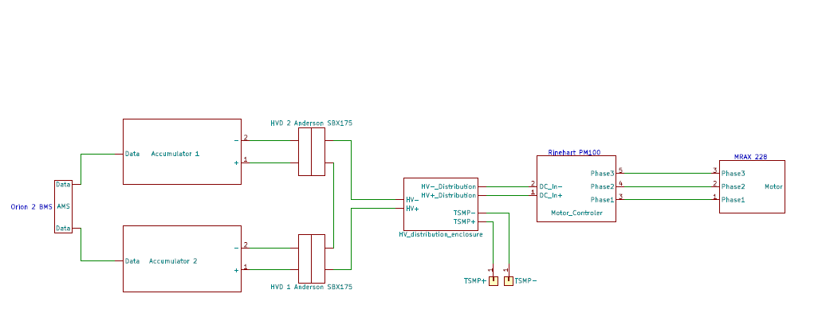

n-BMS

*Figure 1 -* Electrical System Block Diagram (All wiring except for TSMP and Data wires are 25mm^2 shielded dual-insulated. TSMP wires are 16AWG, Data wires are 22 AWG) Note: charging is done through Anderson SBX175 connectors.

*Figure 2 - Drawings showing the vehicle from the front, top, and side*

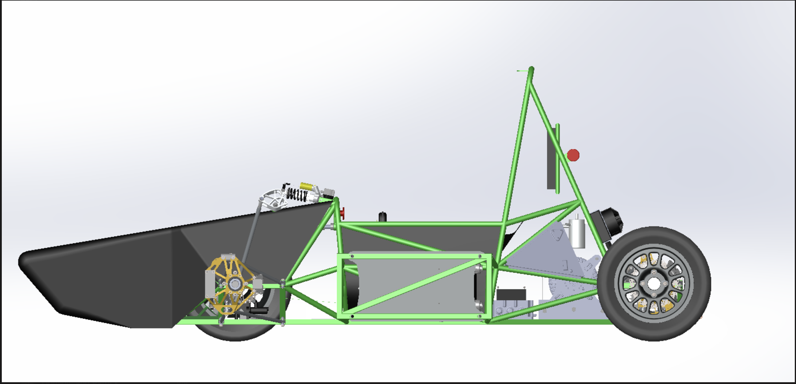

BMS

Motor Controller

Motor

HV Enclosure

Accumulator

*Figure 3 - Locations of all major TS components*

*Figure 4.1 - TSV Wiring Schematic* Battery Pack (This is one side pod, the car has 2) (Battery Pack 1,2 in figure 1) Blue wires represent 22AWG data wires. Green wires are 25mm^2 shielded dual-insulated, or bus bars.

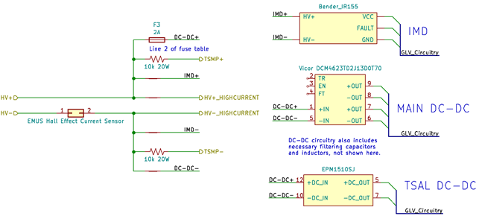

Figure 4.2 – TSV Wiring Schematic—Main HV Distribution Enclosure (HV Distribution Enclosure in Figure 1)

# Operating Voltage

Person primarily responsible for this section:

|  |  |
| --- | --- |
| Name: | Colin Grund |
| e-mail: | cgrund@uvm.edu |

Fill in the following table:

|  |  |
| --- | --- |
| **Item** | **Data** |
| Nominal Tractive System Voltage (TSV*nom*) | 260  VDC |
| Maximum Tractive System Voltage (TSV*max*) | 295 VDC |
| Control System Voltage / Grounded Low Voltage system (GLV) | 12 VDC |

*Table 1- General Electrical System Parameters*

# Safety Circuit

Person primarily responsible for this section:

|  |  |
| --- | --- |
| Name: | Colin Grund |
| e-mail: | cgrund@uvm.edu |

## Shutdown Circuit

*Include a schematic of the shutdown circuit for your vehicle including all major components in the loop*

*Figure 5.1 – Safety Shutdown Circuit Schematic*

Figure 5.2- Latching Circuitry for Fault Interlocks in Shutdown Circuit

*Describe the method of operation of your shutdown circuit, including the master switches, shut down buttons, brake over-travel switch, etc. Also complete the following table*

|  |  |
| --- | --- |
| **Part** | **Function  (Momentary, Normally Open or Normally Closed)** |
| Main Switch (for control and tractive-system; CSMS, TSMS) | Key switch, normally open |
| Brake over-travel switch (BOTS) | Toggle switch, pull to close, push to open |
| Shutdown buttons (BRB) | Toggle button, pull to close, push to open |
| Insulation Monitoring Device (IMD) | Normally open, Momentary Button to close |
| Battery Management System (AMS) | Normally open, Momentary Button to Close |
| Interlocks (if used) | Battery pack connector interlocks - normally closed |

*Table 2 - Switches& devices in the shutdown circuit*

*Describe wiring and additional circuitry controlling AIRs. Write a functional description of operation*

|  |  |
| --- | --- |
| Total Number of AIRs: | 4 |
| Coil holding current per AIR: | 0.1  A |
| Current drawn by other components wired in parallel with the AIRs. | 0  A |
| Total current in shutdown loop: | 0.450  A |

*Table 3 - Shutdown circuit Current Draw*

Provide CAD-renderings showing the shutdown circuit parts. Mark the parts in the renderings

*Figure 6 – Location of Shutdown Circuit Components*

If your shutdown state diagram differs from the one in the Formula Hybrid rules, provide a copy of your state diagram (commented as necessary).

*Figure 7 - Shutdown State Diagram (if non-standard)*

## Shutdown System Interlocks

*(If used) describe the functioning and circuitry of the Shutdown System Interlocks. Describe wiring, provide schematics.*

Interlocks are used on each sidepod battery pack. Because these can be removed from the vehicle, they have a removable disconnect for the high-current path. Normally, if this disconnect was removed while the AIRs were closed, high voltage would be present and exposed at the connector to solve this problem, Anderson SBX175 connectors are used, which include a set of secondary contacts. These secondary contacts carry the current for the AIRs, so the AIRs open when the connectors are removed. These interlocks are shown in Figure 5 and represented by switches.

# Indicator Operation

Person primarily responsible for this section:

|  |  |
| --- | --- |
| Name: | Colin Grund |
| e-mail: | cgrund@uvm.edu |

## Tractive System Active Lamp (TSAL)

*Describe the tractive system active lamp components and method of operation. Describe location and wiring, provide schematics. See* ***EV9.1.***

The TSAL is an LED dome light mounted facing downward at the top of the main roll hoop. It is powered by a Tamura EPM1510SJ DC-DC converter directly connected to TSV post-AIR, which is fed into a team-designed PCB that flashes the TSAL at 2.8Hz with a 20% duty cycle.

## Safety Systems OK Lamp (SSOK)

*Describe the Safety Systems OK Lamp components and method of operation. Describe location and wiring, provide schematics. See* ***EV9.3***

The SSOK lamps are amber LED lamps mounted between the main roll hop and its supports, around the driver’s head level. They are powered directly off the safety loop just before the cockpit BRB, as shown in Figure 5.

## Ready-To-Drive-Sound (RTDS)

*Describe your design for the RTDS system. See* ***EV9.2.***

The RTDS is a Mallory SONALERT SC616N-BTR. This device is capable of producing 105dB 2ft away when powered from its maximum voltage. It is activated when the start button on the dash is pressed, but only if the shutdown loop is closed (SSOK lights are on) and the vehicle is not already ready to drive.

# TSMP

Person primarily responsible for this section:

|  |  |
| --- | --- |
| Name: | Colin Grund |
| e-mail: | cgrund@uvm.edu |

## Tractive System Measurement Points (TSMP)

*The TSMP must comply with FH Rule* ***EV10.3****. Describe the TSMP housing and location. Describe TSMP electrical connection point.*

|  |  |
| --- | --- |
| TSMP Output Protection Resistor Value | 10 kΩ |
| Resistor Voltage Rating | 1000   V |
| Resistor Power Rating | 20   W |

*Table 4 – TSMP Resistor Data*

# Cables & Fusing

Person primarily responsible for this section:

|  |  |
| --- | --- |
| Name: | Colin Grund |
| e-mail: | [cgrund@uvm.edu](mailto:cgrund@uvm.edu) |

## Fusing & Overcurrent Protection

*List data for Primary TS and GLV fuses (or circuit breakers) and cross-reference to schematic.*

|  |  |  |  |  |  |
| --- | --- | --- | --- | --- | --- |
| Mfg. | Fuse Part Number | Cont. Rating (A) | DC Voltage Rating | DC Interrupt Rating (A) | Schematic reference-designators (ref-des) |
| Mersen | MEV70A150-4 | 150A | 700VDC | 20kA | F1, F2, Inside packs |
| Bell | 0ADKC2500-BE | 2A | 500VDC | 300A | F3 |
| Hansor | ATP-L | 30A | 32V | 1000A | GLV main fuse, DC-DC main fuse |
| Littelfuse | 0505020.MXP | 20A | 500VDC | 20kA | TSV charging adapter |

*Table 5 - Fuse Table*

## Component Fusing

*List data sheet max fuse rating for each major component (e.g., motor controller, dc-dc converter, etc.) Ensure that the rating of the fuse used is ≤ the maximum value for the component*

|  |  |  |  |  |  |
| --- | --- | --- | --- | --- | --- |
| Component | Max Fuse Rating per data sheet (A) | Conductor  (Table 7  line number) | Installed Fuse Rating (A) | Fuse Part Number | Notes |
| Energus Li2x4P25RT | 240A | 2 | 150A | MEV70A150-4 | Battery Modules |
| Rinehart PM100DX | 400A | 1 | 150A | MEV70A150-4 | Motor Controller |
| Vicor DCM 4623 | Not listed | 3 | 2A | 0ADKC2500-BE | Main DC-DC |
| Gigavac GV200 | 200A | 1,2 | 150A | MEV70A150-4 | AIRs |

*Table 6 - Component Fuse Ratings*

## System Wire Tables

*List wires and cables used in the Tractive System and the GLV system – (wires protected by a fuse of 1 A or less may be omitted.)*

*Cable capacity is the value from FH Rules* ***Appendix E*** *(Wire Current Capacity).*

|  |  |  |  |  |  |  |  |
| --- | --- | --- | --- | --- | --- | --- | --- |
|  | Mfg. | Part Number | Size AWG / mm2 | Insulation Type | Voltage Rating | Temp. Rating (C) | Current capacity (A) |
| 1 | Champlain Cable | EXRAD HVFX | 25 mm^2 | irradiated cross-linked polyolefin | 1000V | 150C | 190A |
| 2 | Southwire | Royal Excelene | 2 AWG | EPDM | 600V | 105C | 190A |
| 3 | Consolidated Wire | 1015 | 16 AWG | PVC | 600V | 105C | 24A |
| 4 | Consolidated Wire | 1015 | 24 AWG | PVC | 600V | 105C | 7A |
| 5 | Consolidated Wire | 1015 | 12 AWG | PVC | 600V | 105C | 45A |

*Table 7 - System Wire Table*

*(Add additional lines as required)*

# Motors

Person primarily responsible for this section:

|  |  |
| --- | --- |
| Name: | Colin Grund |
| e-mail: | cgrund@uvm.edu |

## Motor(s)

*Describe the motor(s) used. Copy and Paste additional tables if multiple motor types are used*

|  |  |
| --- | --- |
| Manufacturer and Model: | Enstroj EMRAX 228 MV |
| Motor type (PM, Induction, DC Brush) | PMAC |
| Number of motors of this type used | 1 |
| Nominal motor voltage (Vrms l-l or Vdc) | 204 Vrms |
| Nominal / Peak motor current (A or A/phase) | Nom: 106Arms / Peak: 255 Arms |
| Nominal / Peak motor power | Nom: 26.3kW / Peak: 63.1kW |
| Motor wiring – conductor | Table 7 Line Number:1 |

*Table 8 - Motor Data*

*Provide calculations for currents and voltages. State how this relates to the choice of cables and connectors used.*

Phase current was calculated a I_pack/sqrt(2) where I_pack is the average continuous current from the pack, which is designed to be 150A.

## Motor Controller

*Describe the motor controller(s) used. Copy and Paste additional tables if multiple motor controller types are used.*

A single Rinehart Motion Systems (RMS) PM100DX controller is used. This is a liquid-cooled, 3-phase, 100kW controller. It is fully sealed, and all the control I/O is isolated, so it does not need to be placed inside an enclosure.

|  |  |
| --- | --- |
| **Manufacturer** | Rinehart Motion Systems |
| **Model Number** | PM100DX |
| Number of controllers of this type used: | 1 |
| Maximum Input voltage: | 360 V |
| Nominal Input Current (A) | 150 A |
| Output voltage (Vac l-l or Vdc) | 204 Vrms |
| Isolation voltage rating between GLV (power supply or control inputs) and TS connections | 1000V |
| Is the accelerator galvanically isolated from the Tractive System per **EV3.5.7 & EV5.1**? | **X** Yes / ☐ No |

*Table 9 - Motor Controller Data*

*If the answer to the last question is NO, how do you intend to comply with* ***EV3.5*** *(an external isolator is acceptable).*

*Provide calculations for currents and voltages. State how this relates to the choice of cables and connectors used.*

Wiring was selected based on a maximum continuous current of 150A from the battery pack. This is a fuse limitation.

# Isolation & Insulation

Person primarily responsible for this section:

|  |  |
| --- | --- |
| Name: | Colin Grund |
| e-mail: | cgrund@uvm.edu |

## Separation of Tractive System and Grounded Low Voltage System

*Describe how the TS and GLV systems are physically separated (****EV5.3****). Add CAD drawings or photographs illustrating TS and GLV segregation in key areas of the electrical system.*

Spacing is used for nearly all areas where TSV and GLV are in the same area. Spacing is maintained by using PCBs and by using wire clips to hold GLV and TSV wiring away from each other. The exception is the HV distribution enclosure, where spacing cannot always be used for isolation. Instead, FR4 barriers are used to section off regions of the enclosure. Primarily, this segregation is used to isolate HV+ from HV- on the input of the enclosure, as well as isolating the n-BMS current sensor from the low-voltage side of the IMD and the low-voltage side of the team-built multipurpose board in the enclosure. The enclosure will be made of 3d printed PLA and all the surfaces will be lined with FR4. The FR4 barriers are shown in red in the following images.

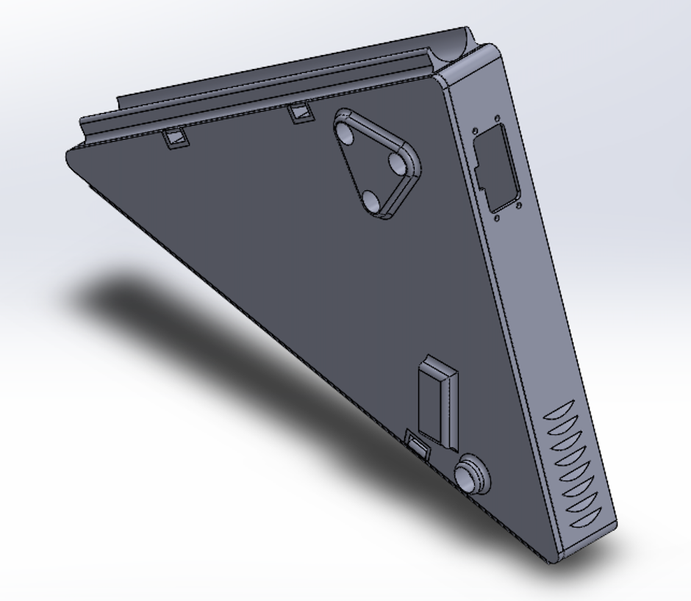

TSMP +/-

GND

Current Sensor

Bender IR155-3904-200kΩ-0V

HV-

HV-

HV+

HV+

*Figure 8 - TS and GLV separation*

## Grounding System

*Describe how you keep the resistances between accessible components below the required levels as defined in FH Rules* ***EV8.1****. If wire is used for ground bonding, state the AWG or mm2 of the wire*

Conductive surfaces are either bolted directly to the frame or are grounded using 16AWG wire.

## Conductive Panel Grounding

*If carbon fiber or coated conductive panels are used in your design, describe the fabrication methods used to ensure point to point resistances that comply with* ***EV8.1.2****. Describe results of*

Conductive panels are not used.

*Figure 9 - Team Designed PCB Layout*

*List all purchased components that have connections to both TS and GLV*

|  |  |  |  |
| --- | --- | --- | --- |
| Component | TS/GLV Isolation (V) | Link to Document Describing Isolation | Notes |
| Vicor DCM 4623 | 4.2kV | <https://www.mouser.com/datasheet/2/685/DCM4623xD2J13D0y7z_ds-1144763.pdf> |  |
| Tamura EPM1510SJ | 3kV | <https://www.tamura-ss.co.jp/en/electronics/pdf/EPM1510SJ_1208AE.pdf> |  |
| Omron G2RL | 5kV | <https://omronfs.omron.com/en_US/ecb/products/pdf/en-g2rl.pdf> |  |
| Rinehart PM100DX | 1kV | <https://evwest.com/support/PMxxx%20Datasheet%2001052012.pdf> |  |
| MuRata NXE1S0505MC | 3kV | <https://power.murata.com/datasheet?/data/power/ncl/kdc_nxe1.pdf> |  |
| Si8602AC | 5kV | <https://www.silabs.com/documents/public/data-sheets/Si860x.pdf> |  |
| LTV817 | 5kV | <http://optoelectronics.liteon.com/upload/download/DS-70-96-0016/LTV-8X7%20series%20201610%20.pdf> |  |
|  |  |  |  |

*Table 10 – Purchased Component*

## Isolation

*Provide a list of containers that have TS and GLV wiring in them. If a barrier is used rather than spacing, identify barrier material used (reference Table 12- Insulating Materials).*

|  |  |  |  |  |  |
| --- | --- | --- | --- | --- | --- |
| Container Name | Segregation by Spacing (Y or N) | How is Spacing maintained | Actual Measured Spacing mm | Alt – Barrier Material P/N | Notes |
| Accumulator Container | Y | PCB, Wire clips | 35 | 1/32” FR4 | * Segregation by spacing where applicable, barrier used when spacing is constricted. |
| HV Distribution Enclosure | Y/N * | PCB, mechanical standoffs | Not constructed yet | 1/32” FR4 | * Segregation by spacing in some places, barrier in other places |

*Table 11 – List of Containers with TS and GLV wiring*

*List all insulating barrier materials used to meet the requirements of* ***EV2.4.3*** *or* ***EV5.4***

|  |  |  |  |  |
| --- | --- | --- | --- | --- |
| Insulating Material / Part Number | UL Recognized(Y / N) | Rated Temperature ºC | Thickness mm | Notes |
| 1/32-inch FR4 | Y | 130 | 0.8 |  |

*Table 12- Insulating Materials*

## Conduit

*List different types of conduit used in the design. Specify location and if manufacturer’s standard fittings are used. Note Virtual Accumulator Housing FH Rules* ***EV2.12*** *requires METALLIC type LFMC.*

*Describe how the conduit is anchored if standard fittings are not used.*

|  |  |  |  |  |  |
| --- | --- | --- | --- | --- | --- |
| Conduit Type | MFR | Part Number | Diameter  Inch or mm | Standard Fittings  (Y or N) | Location / Use |
| PVC | Superflex | Sealproof 8432 | 3/4-inch | Y | Main HV distribution enclosure to TSMP enclosure |

*Table 13 - Conduit Data*

*Is all conduit contained within the vehicle Surface Envelope per* ***EV3.1.6****? (****Y or N****).*

*Does all conduit comply with* ***EV3.2****? (****Y or N****).*

## Shielded dual-insulated cable

*If Shielded, dual-insulated cable per* ***EV3.2.5(a)*** *used in the vehicle, provide specifications and where used:*

|  |  |  |  |  |
| --- | --- | --- | --- | --- |
| MFR | Part Number | Cross Section mm2 | Shield grounded at both ends (Y or N) | Location / Use |
| Champlain Cable | EXRAD HVFX | 25 | Yes | All wiring outside of accumulator packs |

*Table 14 - Shielded Dual Insulated Cable Data*

## Firewall(s)

## Description/materials

*Describe the concept, layer structure and the materials used for the firewalls. Describe how all firewall requirements in FH Rules* ***T4.5*** *are satisfied. Show how the low resistance connection to chassis ground is achieved.*

All firewall is made of 1/32-inch FR4 sheet (equivalency test can be provided). It is located on either side of the driver between the driver and the battery pack, as well as behind the driver, between the driver and the HV distribution enclosure, motor controller, and motor.

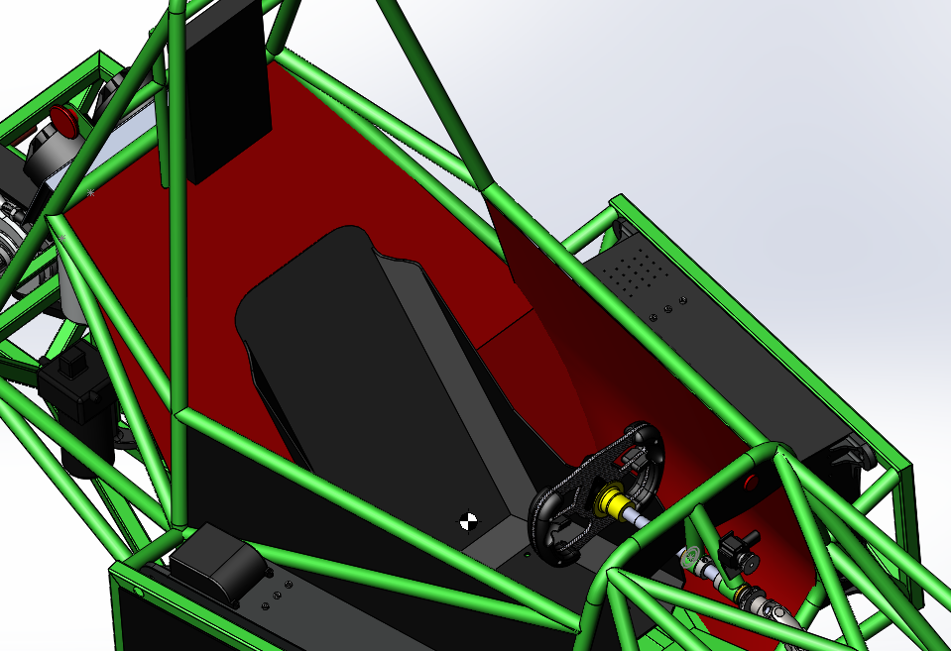

*Fire wall shown in red*

***Position in car*** *Provide CAD-rendering or photographs showing the location of the firewall(s).*

# Printed Circuit Boards

Person primarily responsible for this section:

|  |  |
| --- | --- |
| Name: | Colin Grund |
| e-mail: | cgrund@uvm.edu |

*List all electrical circuit boards designed by team that contain TS and GLV voltage in the following table.*

|  |  |  |  |  |
| --- | --- | --- | --- | --- |
| Device / PCB | TS Voltage Present (V) | Minimum Spacing mm | Thru Air of Over Surface | Notes |
| Battery Pack Board | 288 | 8.25mm | Over surface | The board is mirrored to fit in the packs, both boards shown |
| DC-DC Board | 288 | 10mm | Over surface |  |

*Table 15 - PCB Spacings*

*Add a figure (board layout drawing) for each team-designed PCB showing that spacings comply with* ***EV5.5.***

**DC-DC Board (Both DC-DC converters, fan controller, GLV monitoring):**

Front:

Back:

**Battery Pack Board (Pre-charge/Discharge)**

Board One Front :

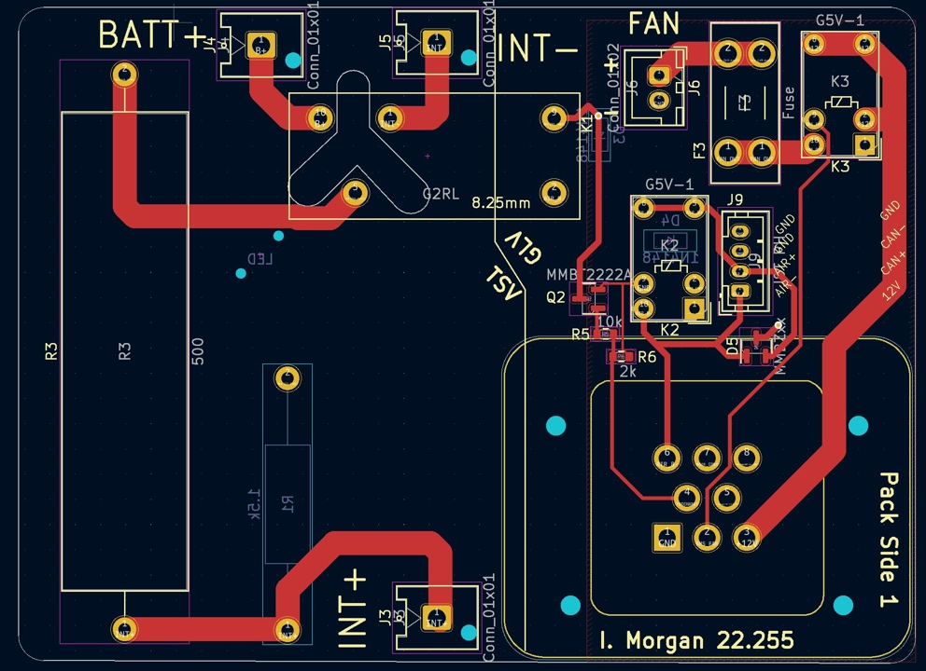

Board One Back:

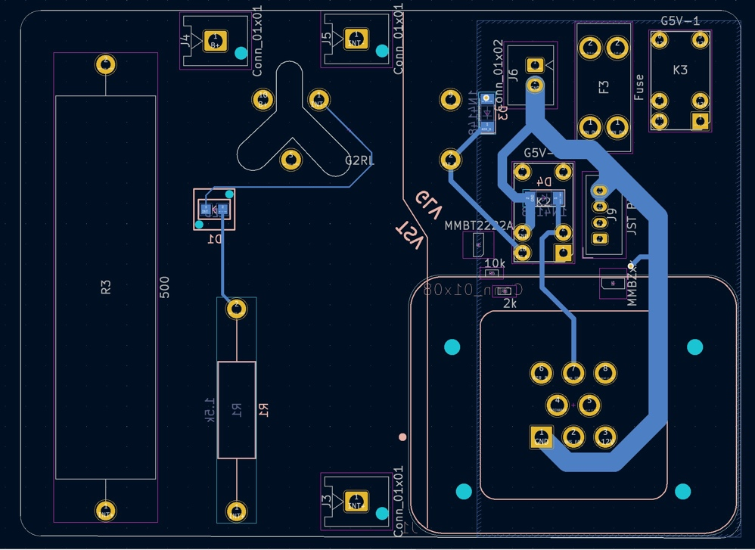

Board Two Front:

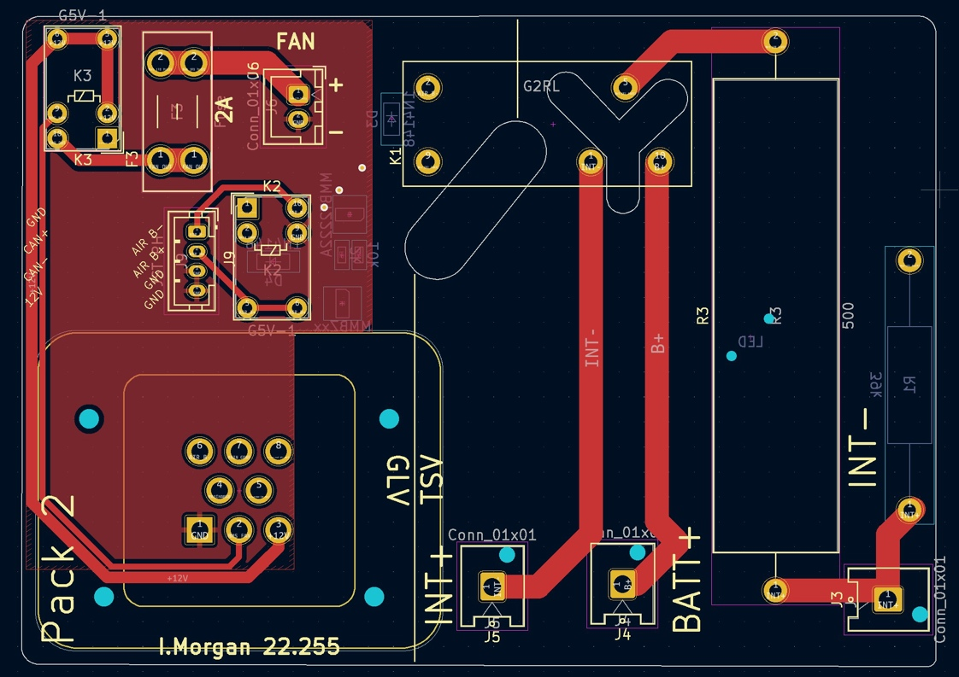

Board Two Back:

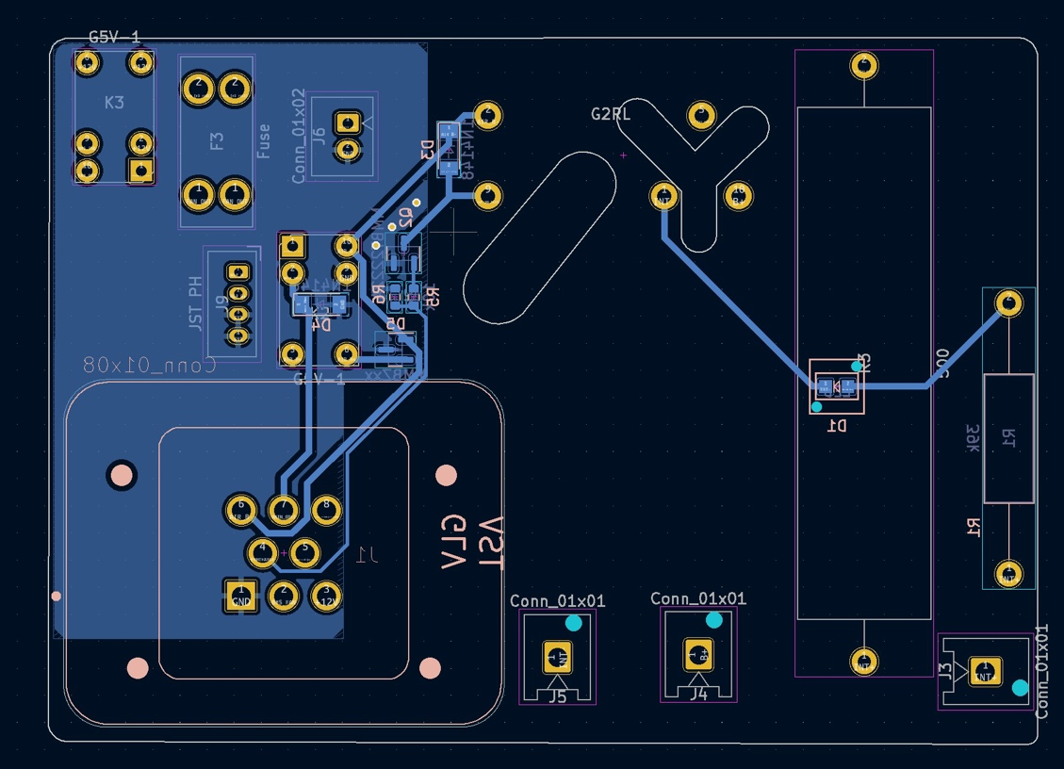

# IMD

Person primarily responsible for this section:

|  |  |
| --- | --- |
| Name: | Colin Grund |
| e-mail: | cgrund@uvm.edu |

## IMD

*Describe the IMD used and use a table for the common operation parameters, like supply voltage, temperature, etc. Describe how the IMD indicator light is wired. Complete the following table.*

|  |  |
| --- | --- |
| MFR / Model | Bender IR155-3904-200kΩ-0V |
| Set response value: | 200 kΩ (694 Ω/Volt) |

*Table 16 - Parameters of the IMD*

*Describe IMD wiring with schematics.*

The IMD is wired directly to HV inside the HV distribution enclosure. The schematic for this is shown in Figure 4.2

## Reset / Latching for IMD and AMS

*Describe the functioning and circuitry of the latching/reset system for a tripped IMD or AMS. Describe wiring, provide schematics.*

Latching circuitry uses Omron G5V-2 relays. This circuitry is nearly identical to the sample latching circuitry shown in the rules.

# AMS

Person primarily responsible for this section:

|  |  |
| --- | --- |
| Name: | Colin Grund |
| e-mail: | cgrund@uvm.edu |

## Accumulator Management System (AMS)

|  |  |
| --- | --- |
| **Manufacturer** | Sensata Technologies |
| **Model Number** | n-BMS |
| Number of AMSs | 1 |
| Upper cell voltage trip | 4.2 V |
| Lower cell voltage trip | 2.5 V |
| Temperature trip | 60 °C |

*Table 17 - AMS Data*

* *Describe how the AMS meets the requirements of* ***EV2.11.***

The n-BMS uses a cell taps in groups of 12 to monitor the voltages of each cell. The cell tap groups the cells in series with a ground reference on the lowest potential in the series. Since the cell boards are grouped in 12 and our segments consist of 18 cells there will be two boards per segment monitoring 9 cells each. The cell boards communicate outside the pack to a main AMS through isoSPI.

* *Describe other relevant AMS operation parameters.*

The n-BMS also uses a hall effect current sensor to measure the current into the motor controller. This is located in our high voltage distribution box.

* *Describe how many cells are monitored by each AMS board, the configuration of the cells, the configuration of the boards and how AMS communications wiring is protected and isolated.*

Each n-BMS board is connected to 9 cells in series. There are two CMU boards per segment for a total of 8 boards in total. They all communicate through isoSPI to the main control unit located near the motor controller. The isolation between TSV and signal is done internally on the cell monitoring boards and through the isoSPI communication protocol.

* *Describe how the AMS opens the AIRs if an error is detected*

The n-BMS main AMS is connected directly to the fault latching circuitry in such a way that it must sink the current needed to hold the latching relay closed. In the case of a fault, the current will be interrupted (the low-side switch turned off), which will open the shutdown loop and turn off the AIRs. The same behavior will be exhibited if the wires connecting either AMS system to the fault latching system are severed or otherwise disconnected.

* *Indicate in the AMS system the location of the isolation between TS and GLV*

The Isolation of TS and GLV is done internally on the n-BMS cell monitering boards. The BMS also has internal isolation monitoring to ensure the separation of TS and GLV and will fault under an isolation fault.

# Accumulator and Container

Person primarily responsible for this section:

|  |  |
| --- | --- |
| Name: | Colin Grund |
| e-mail: | cgrund@uvm.edu |

## Accumulator Pack

*Provide a narrative design of the accumulator system and complete the following table.*

|  |  |
| --- | --- |
| Maximum Voltage (during charging): | 150  VDC |
| Nominal Voltage: | 260  VDC |
| Total number of cells: | 576 |
| Cell arrangement (x in series / y in parallel): | 72/8 |
| Are packs commercial or team constructed? | Commercial cell modules, team-built packs |
| Total Capacity (per FH Rules **Appendix A[2]**): | 4.147  kWh |
| Maximum Segment Capacity | 4.665 MJ |
| Number of Accumulator Segments | 4 |

*Table 18 - Main accumulator parameters*

* Note: Each accumulator container (half total pack) is charged individually, so the charging voltage is only for half of the pack.

*Describe how pack capacity is calculated. Provide calculation at 2C (0.5 hour) rate. How is capacity derived from manufacturer’s data? If so, include discharge data or graph here. Include Peukert calculation if used (See FH Rules* ***Appendix A****)*

Pack capacity is calculated using the 2C discharge rate provided in the Samsun INR18650-25R datasheet (shown below). The pink line represents 5A discharge, which is 2C for these 2.5Ah cells.

$$Capacity=V_{cell}*Ah_{cell}*numcells*0.8=3.6V*2.5Ah*576*0.8=4147Wh$$

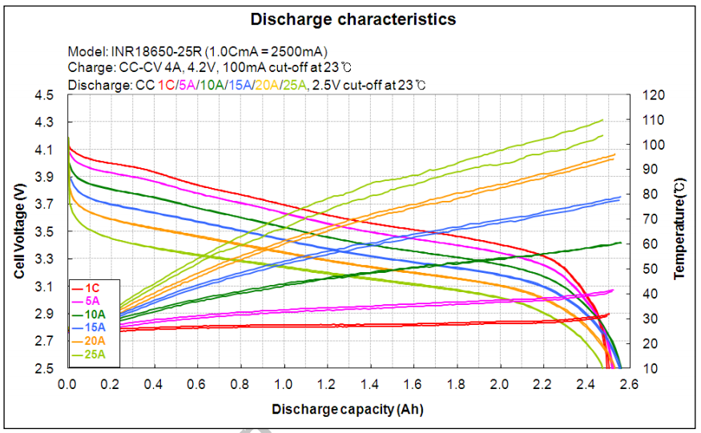

*Show your segment energy calculations. The segment energy is calculated as:*

$$Vnom x Cell AH \left(2C rate\right) x Number of Cells x 3.6 \left(kJ\right)$$

(Note: The 80% factor is not applied for this calculation.)

Calculation:

$$3.6Vx2.5Ahx144cells\left[1segment\right]x3.6\left(kJ\right)=4.665MJ$$

## Cell description

*Describe the cell type used and the chemistry and complete the following table.*

|  |  |
| --- | --- |
| Cell Manufacturer | Samsung (cell) / Energus (module) |
| Model Number | INR18650-25R / Li2x4P25RT |
| Cell type (prismatic, cylindrical, pouch, etc.) | Cylindrical |
| Are these pouch cells | ☐Yes / X No |
| Cell nominal capacity at 2C (0.5 hour) rate: | 2.45 Ah |
| Data sheet nominal capacity | 2.45 Ah at 2C rate |
| Maximum Voltage (during charging): | 4.2 V |
| Nominal Voltage (data sheet value): | 3.6 V |
| Minimum Voltage (AMS setting): | 2.5 V |
| Maximum Cell Temperature (charging - AMS setting) | 45 °C |
| Maximum Cell Temperature (discharging - AMS setting) | 60 °C |
| Cell chemistry: | Li-ion |

*Table 19 - Main cell specification*

***IMPORTANT:*** *Show your calculations here for 2C nominal AH capacity if the data sheet uses a different discharge rate. Refer to FH rules* ***Appendix A***

## Cell configuration

*Describe cell configuration, show schematics, cover additional parts like internal cell fuses etc.*

*Describe configuration: e.g., N cells in parallel then M packs in series, or N cells in series then M strings in series.*

The vehicle has two battery packs, one on each side, wired in series. Each pack has 36 Energus Li2x4P25RT modules in series, split in two segments of 18. Each Energus module has 8 Samsung INR18650 25R cells in parallel. The parallel cells in the Energus modules are connected with fusible links that are designed to open after a 10 second pulse of 360 amps. These fuses are described in the module datasheet.

*Does the accumulator combine individual cells in parallel without cell fuses?* ☐Yes / X No

*If Yes, explain how* ***EV2.6.3*** *is satisfied.*

## Segment Maintenance Disconnect

*Describe segment maintenance disconnect (SMD) device, locations, ratings etc.*

|  |  |
| --- | --- |
| Is HVD used as an SMD? | ☐Yes / X No |
| Number of SMD Devices / Number of Segments | 2/4 |
| SMD MFR and Model | Anderson SBX175 |
| SMD Rated Voltage (if applicable) | 600 V |
| SMD Rated Current (if applicable) | 175 A |
| Segment Energy (6 MJ max[3]) | 4.665 MJ |
| Segment Energy Discharge Rate (Ref FH Rules **Appendix A**) | ------------- C |

*Table 20 - SMD Data*

## Lithium-Ion Pouch Cells

*The vehicle accumulator uses individual pouch cells.* Yes ☐ No X

Note that designing an accumulator system utilizing pouch cells is a substantial engineering undertaking which may be avoided by using prismatic or cylindrical cells.

*If your team has designed your accumulator system using individual Lithium-Ion pouch cells, include drawings, photographs and calculations demonstrating compliance with all sections of rule* ***EV11.*** *If your system has been issued a variance to* ***EV11*** *by the Formula Hybrid rules committee, include the required documentation from the cell manufacturer along with a copy of the variance.*

## Cell temperature monitoring

*Describe how the temperature of the cells is monitored, where the temperature sensors are placed, how many cells are monitored, etc. Show a map of the physical layout. Provide schematics for team-built electronics.*

*The cell temperature is monitored using the built in energus sensors. The sensors are connected two in parallel to an esp32 WROOM analog pins. The esp32 uses an output that is connected to the n-BMS programmable I/O pins, that is high clear and low fault.*

|  |  |
| --- | --- |
| Number of Cells with Temperature Monitoring | 576 |
| Total Number of Cells | 576 |
| Percentage Monitored $(monitored / total)$ | 100% |
| Percentage Required by FH Rules: **Table 11** | 30% |
| If each sensor monitors multiple cells, state how many: | 2 |

*Table 21 - Cell Temperature Monitoring*

## Accumulator Isolation Relays (AIR)

*Describe the number of AIRs used and their locations. Also complete the following table.*

|  |  |
| --- | --- |
| **Manufacturer** | Gigavac |
| **Model Number** | GV200 |
| Contact arraignment: | SPST |
| Continuous DC current rating: | 200 A |
| Overload DC current rating: | **Curve, shown below |
| Maximum operation voltage: | 800 VDC |
| Nominal coil voltage: | 12 VDC |
| Normal Load switching: | Make and break up to _____ A |

*Table 22 - AIR data*

GV200 overload current curve: (y-axis is time in seconds)

## Accumulator wiring, cables, current calculations

*Describe internal wiring with schematics if appropriate. Provide calculations for currents and voltages and show data regarding the cables and connectors used. Discuss maximum expected current, whether DC or AC, and duration Compare the maximum values to nominal currents*

## Accumulator indicator

*If accumulator container is removable, describe the voltage indicator, including indicating voltage range*

The accumulators are removable, and a simple LED indicator is used. The LED will turn on when the voltage on the AIR side of the pack is above 60V.

## Accumulator Container/Housing

*Describe the design of the accumulator container. Include the housing material specifications and construction methods. Include data sheets for insulating materials. Include information documenting compliance with UL94-V0, FAR25 or equivalent.*

*If the housing is made of conductive material, include information on how the poles of the accumulators are insulated and/or separated from the housing, and describe where and how the container is grounded to the chassis.*

*Include additional photographs if required, to illustrate compliance with rule* ***EV2.4.***

*Show how the cells are mounted, use CAD-Renderings, sketches or photographs showing compliance with FH Rule* ***EV2.4.7.***

Cells are housed securely inside the enclosure by press-fit FR4 lining on the steel walls (This also covers the steel to eliminate conductive penetration). Additionally, the cells are held in place by a polycarbonate spacer that sits on top of them and presses on them on all exposed surfaces on the top of the Energus modules between bus bars. This spacer is pressed against the cells the lid of the enclosure through a piece of dense foam that provides even pressure against the cells.

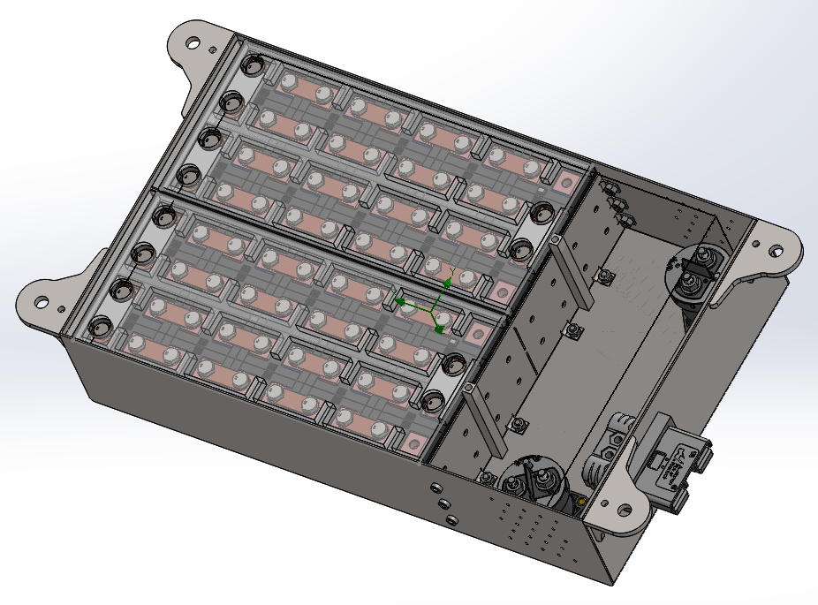

Internals of the battery pack, showing the two segments and all Energus modules, as it would be assembled.

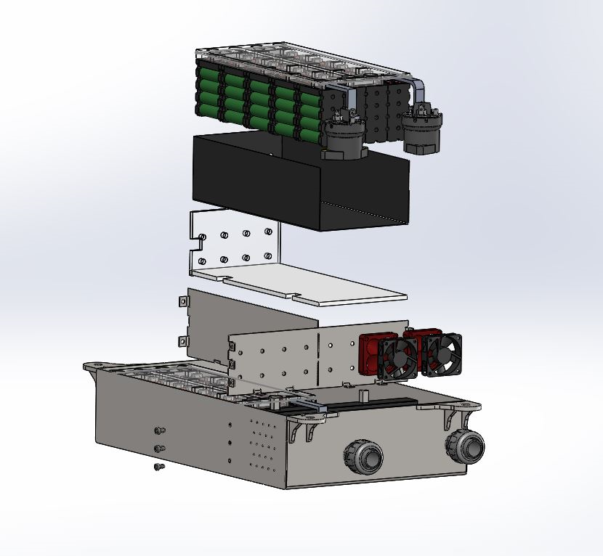

Exploded view – shows steel construction, polycarbonate sheets below and in front of the cells, FR4 lining, and one segment of Energus modules.

## HV Disconnect (HVD)

*Describe your design for the HVD and how it is operated, wiring, and location. Describe how your design meets all requirements for* ***EV2.9.***

The connectors for the accumulator packs are used as the HVD, meaning that the vehicle has two HVDs, one on each side. One side of this connector is solidly mounted to the battery pack, making it easy to remove the mating side. The connectors have a handle on them for easy removal.

# Pre-charge / Discharge

Person primarily responsible for this section:

|  |  |
| --- | --- |
| Name: | Colin Grund |
| e-mail: | cgrund@uvm.edu |

## Pre-Charge circuitry

*Describe your design for the pre-charge circuitry. Describe wiring, connectors and cables used.*

* *Include a schematic of the pre-charge circuit*
* *Include a plot of calculated TS Voltage vs. time*
* *Include a plot of calculated Current vs. time*
* *Include a plot of resistor power vs time.*

*Pre-charge/Discharge Circuitry*

The pre-charge circuit is controlled by the Rinehart controller. The controller first outputs a pre-charge signal to begin the pre-charge process, then outputs a main-contactor signal once it determines that the voltage on its input is high enough. The pre-charge procedure is as follows:

1. AIR1 turned on when shutdown loop is closed, connecting B- to the intermediate circuit
2. Pre-charge relay turned on once the Rinehart pre-charge signal goes high, connecting B+ to the intermediate circuit through the resistor
3. AIR2 turned on when the Rinehart main-contactor signal goes high.

INT+ and INT- are the positive and negative poles of the intermediate circuit, i.e. the output of the battery pack after the AIRs. SHDN_IN is the shutdown loop, tapped off of the input to the AIRs after the TSMS. MAIN_CONT and PRECHARGE are the Rinehart signals. Finally, B+ is the positive battery connection. This circuit is included in both side-pod battery packs, so the two pre-charge resistors will work in series, for a total resistance of 2k ohms. Below is a plot of voltage and power vs time. The blue line is voltage on the intermediate circuit, and the red line is power dissipated by the two resistors (one resistor would dissipate half the total power shown on the graph).

*Provide the following information:*

|  |  |
| --- | --- |
| Resistor Type: | Wirewound |
| Resistance: | 1000  Ω |
| Continuous power rating: | 7  W |
| Overload power rating: | 50 W for 0.1 sec |
| Voltage rating: | 1000  V |

*Table 23 - Data for the pre-charge resistor*

|  |  |
| --- | --- |
| Relay MFR & Type: | Omron G2RL |
| Contact arrangement: (e.g. SPDT) | SPDT |
| Continuous DC contact current: | 12 A |
| Contact voltage rating: | 300 Vdc |

*Table 24 - Data of the pre-charge relay*

## Discharge circuitry

*Describe your concept for the discharge circuitry. Describe wiring, connectors and cables used.*

* *Include a schematic of the discharge circuit*
* *Include a plot of calculated TS Voltage vs. time*
* *Include a plot of calculated “Discharge current” vs. time*
* *Include a plot of resistor power vs time.*

As shown above, the discharge circuitry is included in the pre-charge circuitry. When the pre-charge relay is turned off, the resistor is connected between the positive and negative poles of the intermediate circuit, which discharges it. The following plot shows the discharge curve.

*Provide the following information:*

|  |  |
| --- | --- |
| Resistor Type: | Wirewound |
| Resistance: | 1000  Ω |
| Continuous power rating: | 7  W |
| Overload power rating: | 50  W for ___0.1 sec |
| Voltage rating: | 1000  V |
| Maximum expected current: | 0.3  A |
| Average current: | 0.03  A |

*Table 25 - Discharge circuit data*

# Torque Control

Person primarily responsible for this section:

|  |  |
| --- | --- |
| Name: | Colin Grund |
| e-mail: | cgrund@uvm.edu |

## Accelerator Actuator / Throttle Position Sensor

*Describe the accelerator actuator and throttle position sensor(s) used, describe additional circuitry used to check or condition the signal going to the motor controller. Describe wiring, cables and connectors used. Provide schematics and a description of the method of operation of any team-built signal conditioning electronics. Explain how your design meets all of the requirements of FH Rules* ***IC1.6*** *and* ***EV3.5.***

|  |  |
| --- | --- |
| Actuator / Encoder manufacturer | CTS |
| Model Number | 703-99-003 |
| Encoder type (e.g.Potentiometer): | Dual potentiometer |
| Output: | Linear ratiometric based on input voltage  Pot1: 15%-92%  Pot2: 0.75%-46% |
| Is motor controller accelerator signal isolated from TSV? | X Yes / ☐ No |
| If no, how will you satisfy rule **EV3.5**? |  |

*Table 26 - Throttle Position encoder data*

## Accelerator / throttle position encoder error check

*Describe how the system reacts if an error (e.g. short circuit or open circuit or equivalent) is detected. Describe circuitry used to check or condition the signal going to the motor controller. Describe how failures (e.g. Implausibility, short circuit, open circuit etc.) are detected and how the system reacts if an error is detected. State how you comply with* ***EV3.5.4.***

The dedicated microcontroller compares the two throttle potentiometer values to ensure they match, as well as validating the range of each value. If the values either don’t match or either value is out of the expected range, the microcontroller will output a throttle value of zero to the motor controller.

# GLV

Person primarily responsible for this section:

|  |  |
| --- | --- |
| Name: | Colin Grund |
| e-mail: | cgrund@uvm.edu |

## GLV System Data

*Provide a brief description of the GLV system and complete the following table*

GLV is powered primarily by a 400W Vicor DC-DC converter connected to TSV, but is supplemented with a small lead acid battery which is mostly used for startup. The GLV system is 12V and must supply a maximum of 30A, which is primarily drawn by the cooling system.

|  |  |
| --- | --- |
| GLV System Voltage (Same as Table 1) | 12 V |
| GLV Main Fuse Rating | 30 A |
| Is a Li-Ion GLV battery used? | ☐Yes / X No |
| If Yes, is a firewall provided per **T4.5.1**? | ☐Yes / ☐ No |
| Is a dc-dc converter used from TSV? | X Yes / ☐ No |
| Is the GLV system grounded to chassis? | X Yes / ☐ No |
| Does the design comply with all requirements of **EV4**? | X Yes / ☐ No |

*Table 27- GLV System Data*

# Charger

Person primarily responsible for this section:

|  |  |
| --- | --- |
| Name: | Colin Grund |
| e-mail: | cgrund@uvm.edu |

## Charging

*Describe how the accumulator will be charged. How will the charger be connected? How is the accumulator to be supervised during charging? Include a diagram showing how the charging circuit is fused.*

Each side-pod pack is charged separately on the car with an Elcon PFC 1500 charger. A separate enclosure is used to adapt the Anderson SB50 connector on the charger to the Anderson SBX175 connector on the pack. This enclosure also includes fuses (shown below). The accumulator is monitored with the n-BMS. The BMS monitors cell voltage and temperatures, controlling the charger through a relay. If the cells get out of the acceptable range of values set on the BMS, it will open the relay and turn off the charger.

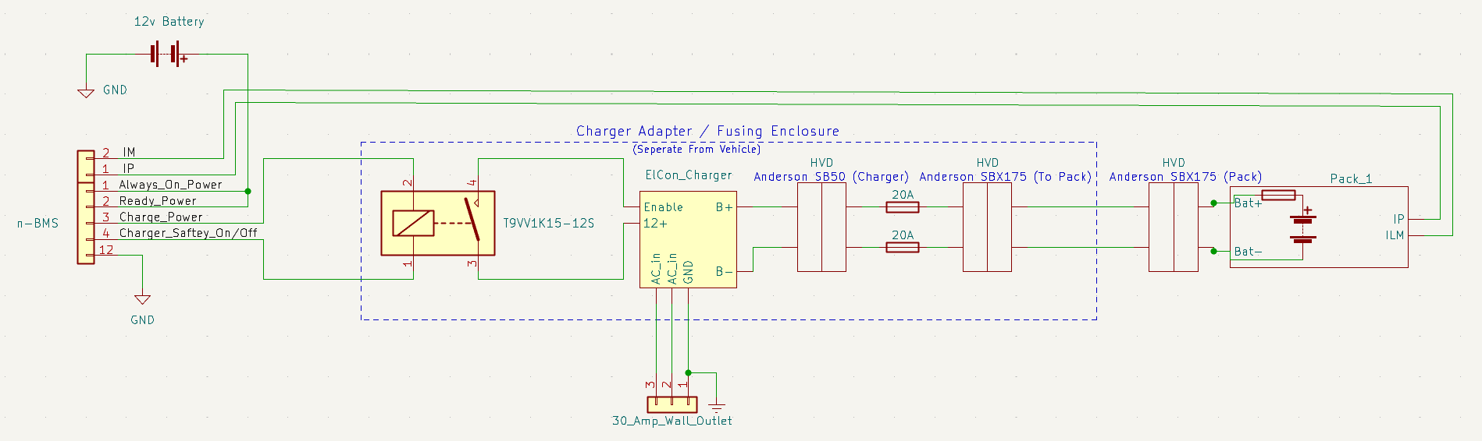

*Figure 10 – Charging Circuit with fusing*

*Complete the table*

|  |  |
| --- | --- |
| **Charger Manufacturer** | Elcon |
| **Model Number** | PFC 1500 |
| Maximum charging power: | 1.5 kW |
| Mains Isolation | X Yes / ☐ No |
| UL Certification  If “no”, fill in the line below. | ☐Yes / X No |
| Do you have a waiver from the FH rules committee?  If “yes”, attach printout of the waiver. | ☐Yes / X No  Will Obtain One |
| Maximum charging voltage: | 168 V |
| Maximum charging current: | 11.2 A |
| Interface with accumulator (e.g. CAN, relay etc.) | Relay |
| Input voltage: | 120 VAC (single phase) |
| Input current: | 12.5 A |

*Table 28 - Charger data*

# Appendices

Include only highly-relevant data. A link to a web document in the ESF text is often more convenient for the reviewer.

The specification section of the accumulator data sheet, and sections used for determining accumulator capacity (FH Rules **Appendix A**) should be included here.

1. HIP does not need to be declared prior to the competition. If unsure, check “Hybrid”
2. This includes an 80% derating for available traction energy
3. Note *Segment energy = rated AH x nominal voltage*. The 80% derating is NOT applied for this calculation.